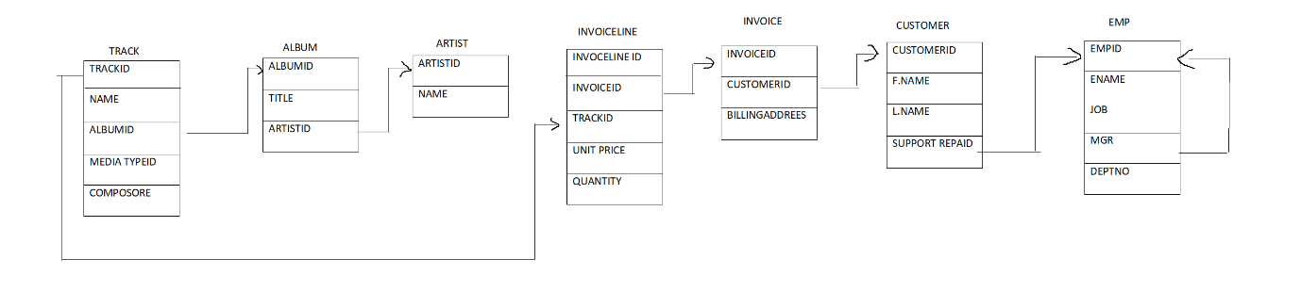

WAQTD THE EMPLOYEE NAME IF THE INVOICE ID IS 7839

WAQTD THE NAME OF TRACK IF THE TRACK TITLE WAS CREATED BY A ARTIST NAMED BHARAT.

WAQTD NAME OF THE ARTIST WHO AS NOT CREATE A ALBUM.

WAQTD EMPLOYEE NAME AND CUSTOMER FIRST NAME IF EMPLOYEE HAS NOT HAVING A REPORTING MANAGER.

WAQTD THE EMPLOYEE NAME IF THE CUSTOMER HAD BOUGHT THE TRACK NAMED ANIMALS